Grading in Self-Service
Updated 11/14/2022

Contents
Table of Contents 1
Step 1: Log into Self-Service 2
Step 2: From your Self-Service Home page, select the Faculty menu: 3
Step3: Expand the Faculty menu by clicking on the down arrow and then click on Faculty Overview: 3
Step 4: Sections that you are teaching are organized by term. Scroll to find the section that you want to drop students and select the section by clicking on the section name: 4
Step 5: Your Section Details will open. 4
Step 6: Click on the Grading tab to open the Grading Overview: 5
Step 7: Click on the Final Grade tab: 6
Step 8: Select a grade from the drop-down under the Final Grade column: 7
Step 9: Once you have entered all of your grades, click on the blue Post Grades button at the top, right-hand corner of your grading roster 7
Step 10: You will be presented with a grade post confirmation pop-up. Click on Post Grades to confirm: 8
Step 11: If your grades have posted successfully, the grades will no longer be editable (the drop-down will disappear): 8
Step 12: To view your posted grades, click on the Overview tab: 9
Notes on Grading 9

Step 1: Log into Self-Service

Log into Self-Service.
The direct link is https://colss-prod.cloud.rsccd.edu/Student/) but links can also be accessed by going to the www.sac.edu or www.sccollege.edu websites and clicking on the following:
From SAC’s website (www.sac.edu):
Click on WEBADVISOR on the top navigation bar:

Click on Self-Service:
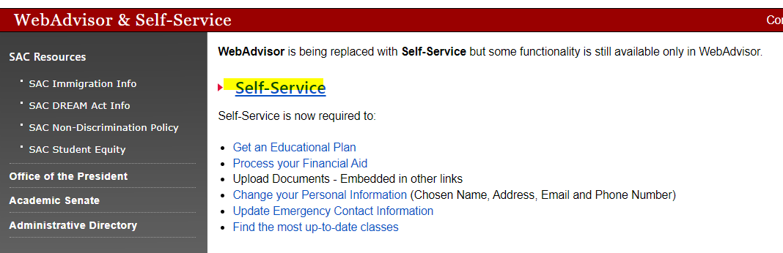
From SCC’s website (www.sccollege.edu):
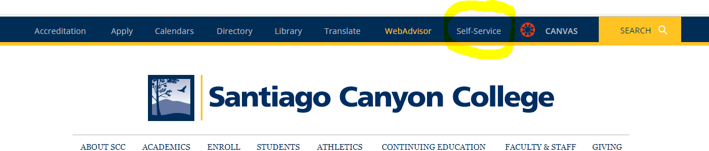
Log in with your district email address as your username and the password you use to log into our systems.

Step 2: From your Self-Service Home page, select the Faculty menu:
Click on the Faculty tile on your Home page:
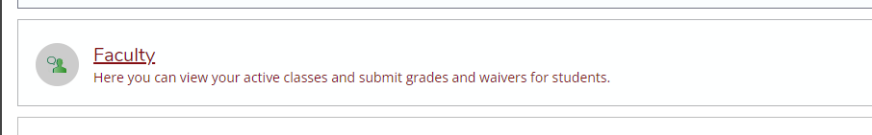
--OR—
You can access the Faculty menu in the left navigation by expanding the Daily Work menu (briefcase icon):
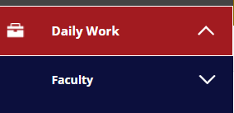

Step3: Expand the Faculty menu by clicking on the down arrow and then click on Faculty Overview:

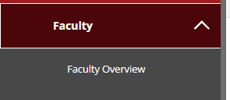

Step 4: Sections that you are teaching are organized by term. Scroll to find the section that you want to drop students and select the section by clicking on the section name:
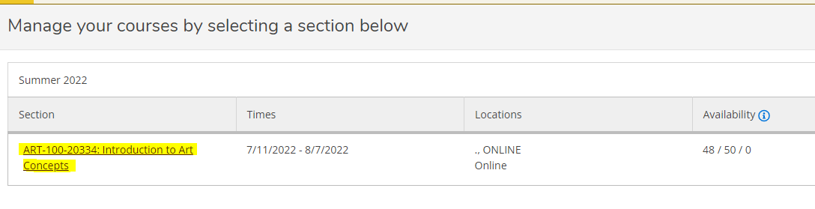

Step 5: Your Section Details will open.
By default, your roster will be displayed towards the bottom of the Section Details page:
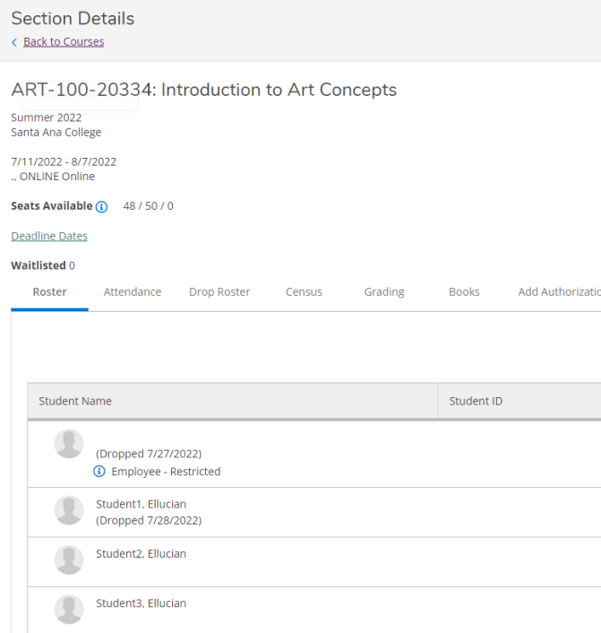

Step 6: Click on the Grading tab to open the Grading Overview:
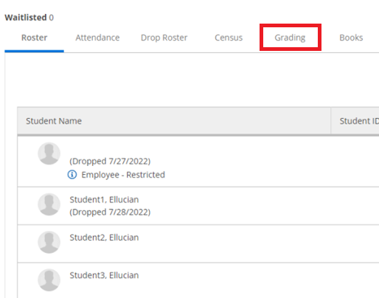

Step 7: Click on the Final Grade tab:
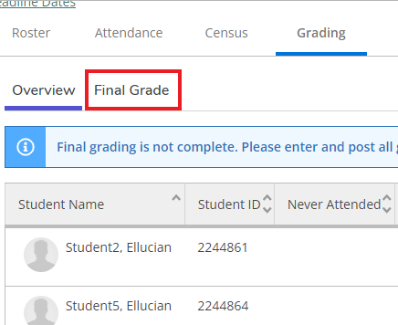
Step 8: Select a grade from the drop-down under the Final Grade column:
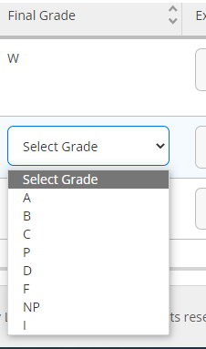

Step 9: Once you have entered all of your grades, click on the blue Post Grades button at the top, right-hand corner of your grading roster:
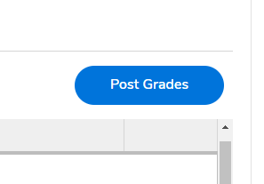

Step 10: You will be presented with a grade post confirmation pop-up. Click on Post Grades to confirm:
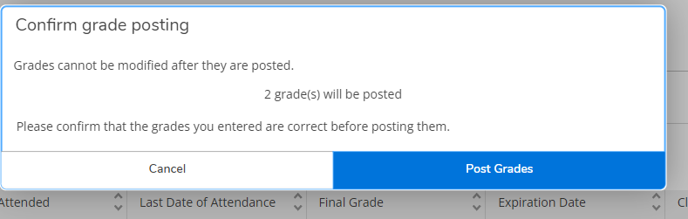

Step 11: If your grades have posted successfully, the grades will no longer be editable (the drop-down will disappear):
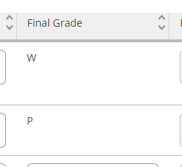

Step 12: To view your posted grades, click on the Overview tab:
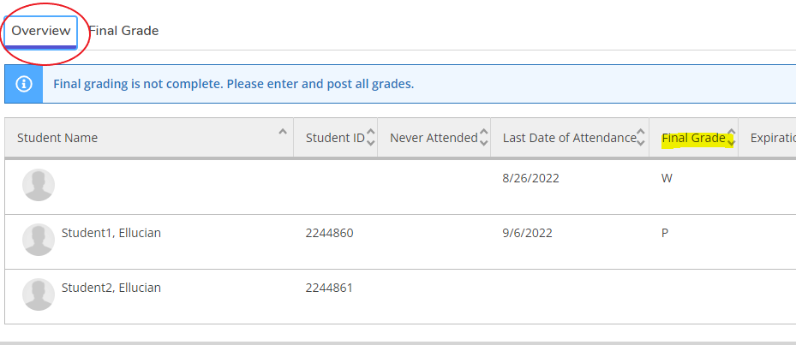

Notes on Grading
- You do not have to grade your students at the same time. You can post grades a little at a time if you prefer, but you MUST post the grades for them to become final and verified.
- Once you’ve clicked on Post Grades and confirmed you can not go back and change your grades.

